**Documentation: Investor Analysis on Stock Market**

# Introduction:

Stock analysis plays a pivotal role in the financial decision-making process, offering insights into investment opportunities and market dynamics. Traditionally, investors have relied on historical data and simplistic models to guide their decisions. However, in today's dynamic market environment, these traditional methods may fall short in capturing the complexities of stock market behavior. To address this challenge, our project focuses on enhancing stock analysis through simulation and modeling techniques.

In our project, we delve into the realm of stock analysis using advanced simulation and modeling methodologies. By leveraging algorithms and computational tools, we aim to provide investors with a deeper understanding of market trends, particularly through analyzing buying and selling pressure/momentum dynamics. This approach allows us to explore market behavior in a more dynamic and predictive manner, offering valuable insights for investment decision-making.

Simulation and modeling offer a promising approach for revolutionizing stock analysis. By incorporating dynamic factors and predictive capabilities, these techniques enable investors to navigate the complexities of the stock market with greater confidence and precision. Our project aims to shed light on the transformative potential of simulation and modeling in enhancing stock analysis, paving the way for more informed and profitable investment strategies.

To put it simply, our goal is to make stock market predictions more accurate and reliable. By using advanced computer models, we can simulate different market scenarios and understand how various factors influence stock prices. This can help investors make better decisions, as they can see potential outcomes and adjust their strategies accordingly.

One key aspect of our approach is the use of algorithms. These are sets of rules or instructions that a computer follows to solve problems. In the context of stock analysis, algorithms can process vast amounts of data quickly and identify patterns that might not be obvious to human analysts. This means we can predict market trends more effectively and respond to changes more rapidly.

Additionally, our project emphasizes the importance of understanding market momentum, which is the rate at which stock prices change. By analyzing buying and selling pressures, we can gain insights into the overall market sentiment and identify potential turning points. This information is crucial for investors looking to maximize their returns and minimize risks.

In conclusion, our project represents a significant step forward in stock analysis. By harnessing the power of simulation and modeling, we aim to provide investors with tools that offer a more comprehensive and nuanced understanding of the stock market. This not only enhances their ability to make informed decisions but also contributes to the development of more robust and resilient investment strategies.

# Problem Statement:

We have chosen this topic due to the urgent need for investors to adapt to the rapidly changing stock market environment. Current market conditions are highly volatile and uncertain, making traditional methods insufficient for accurate stock analysis. By focusing on advanced simulation and modeling techniques, we aim to provide investors with the necessary tools and insights to navigate these challenges more effectively. These methods can better capture the dynamic nature of market behavior, offering a sophisticated approach to investment decision-making that addresses safety concerns more comprehensively.

The stock market's increasing complexity, driven by factors such as global economic shifts, geopolitical tensions, and technological disruptions, demands more adaptive analysis methods. Traditional models, which rely on historical data, often fail to predict rapid market movements influenced by algorithmic and high-frequency trading. Leveraging big data and advancements in computational power, our project integrates simulation and modeling to process vast amounts of real-time data, providing deeper insights into market dynamics. This proactive approach aims to equip investors with the analytical tools necessary to thrive in today's volatile market environment, ultimately aiding in making better-informed decisions.

# Objective:

The objective of our project is twofold:

1. Firstly, to analyze market trends through buying and selling pressure/momentum dynamics, providing investors with a comprehensive understanding of market behavior.
2. Secondly, to explore the benefits of simulation and modeling in stock analysis, demonstrating their potential in enhancing predictive capabilities and informing investment decisions.

# Scope and Limitation:

## **Scope:**

**Our project has a broad and ambitious scope, aimed at enhancing the understanding and application of simulation and modeling techniques in stock analysis. We focus on several key areas:**

**1.Market Trend Analysis: We analyze historical and real-time market data to identify patterns and trends. This involves studying various market indicators, economic factors, and investor behaviors that influence stock prices.**

**2. Simulation Techniques: We explore different simulation methodologies, such as Monte Carlo simulations and agent-based models, to create dynamic representations of market behavior. These simulations allow us to experiment with various scenarios and observe potential outcomes.**

**3. Modeling Approaches: Our project utilizes advanced computational models, including machine learning algorithms and predictive analytic, to enhance the accuracy and reliability of stock market forecasts. We aim to develop models that can adapt to changing market conditions and provide real-time insights.**

**4. Application in Stock Analysis: We apply our simulation and modeling techniques to actual stock market data, aiming to provide practical tools and insights for investors. This includes developing decision-support systems that help investors evaluate risks and opportunities.**

**5. Educational Component: We aim to contribute to the academic and professional community by sharing our findings and methodologies. This includes publishing our results, presenting at conferences, and providing educational resources for students and practitioners.**

**Limitations:**

**While our project aims to make significant advancements in stock analysis, it is important to acknowledge certain limitations:**

1. **Data Quality and Model Complexity: The accuracy and reliability of our simulation results are heavily dependent on the quality of the data and the complexity of the models we use. Incomplete or biased data can lead to inaccurate predictions.**

**2. Predictive Limitations: Despite the advanced techniques employed, simulation and modeling cannot guarantee precise predictions of future market behavior. Markets are influenced by numerous unpredictable factors, such as geopolitical events and sudden economic shifts, which can impact the accuracy of our models.**

**3. Resource Constraints: The scope of our project is limited by available time and resources. This can affect the depth and breadth of our analysis, potentially restricting the range of scenarios we can explore and the detail of our findings.**

**4. Technical and Knowledge Challenges: Implementing advanced simulation and modeling techniques requires significant computational power and expertise. Technical limitations may affect the scalability and efficiency of our models. Additionally, the complexity of these methods demands a high level of knowledge and understanding in both financial theory and computational techniques. Any gaps in expertise can hinder the development and implementation of effective models.**

**5. External Validity: Our models and findings may have limitations when applied to different market conditions or geographical regions. The specific characteristics of different stock markets may affect the generalizability of our results.**

6. Predictive Limitations: Despite the advanced techniques employed, simulation and modeling cannot guarantee precise predictions of future market behavior. Markets are influenced by numerous unpredictable factors, such as geopolitical events and sudden economic shifts, which can impact the accuracy of our models.

**Methodology:**

Our methodology represents a comprehensive and systematic approach to stock analysis, integrating advanced techniques and leveraging Python-based tools such as Jupyter Notebook and OpenCV. This multi-faceted approach encompasses various stages, each meticulously designed to extract meaningful insights and drive informed decision-making in the dynamic realm of financial markets.

**Our approach is based on an advanced computational framework that has been precisely designed to analyze market movements with unmatched accuracy. We dig deeply into the details of market dynamics, interpreting patterns and revealing hidden correlations that support stock price movements by utilizing advanced computer algorithms.**

**By comparing simulated results with historical data, we implement a thorough validation procedure to guarantee the accuracy and reliability of our evaluations. This thorough comparison not only confirms the effectiveness of our models but also acts as an indicator for their predictive ability.**

**When it comes to gathering and pre-processing data, we do not reduce any corners. We carefully select datasets from reliable sources and thoroughly check them for accuracy and completeness. We make sure that the high-quality data that forms the basis of our analysis is cleaned and normalized.**

**We continue the trip by using advanced machine learning algorithms, which allow us to use machine learning to find hidden patterns and trends within the data. We aim for constant progress, trying to stay ahead of the curve in a constantly changing landscape by repeatedly improving our models and adjusting parameters.**

**We seek to strengthen our approach to stock analysis by a process of iterative validation and improvement, which will result in a strong framework that sustains throughout time. Our ultimate objective is to equip stakeholders with practical insights so they may confidently and quickly negotiate the complexity of the financial markets.**

# ****Tools Used****

* Data Loading and Pre-processing: Pandas, NumPy.
* Data Scaling: Scikit-Learn.
* Model Building and Training: TensorFlow (Keras).
* Visualization: Matplotlib.

# High level design of proposed system

## Use case Diagram:

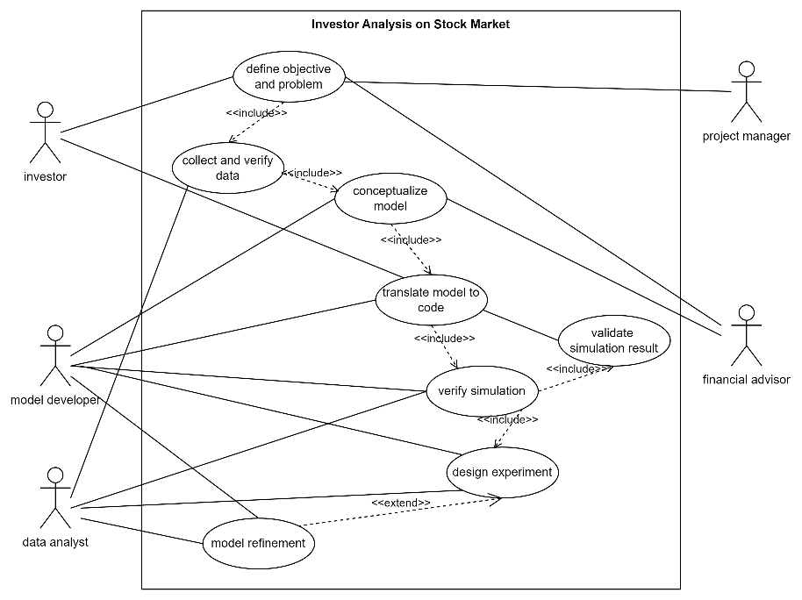The use case diagram for the "Investor Analysis on Stock Market" simulation project illustrates a systematic approach to understanding stock market behavior. The project involves various actors, including Investors, Data Analysts, Model Developers, Financial Advisors, and Project Managers, each playing a crucial role. Key functions encompass defining problems and objectives, collecting and verifying data, conceptualizing and coding the model, running simulations, and analyzing results. The iterative process includes refining the model based on simulation outcomes and documenting findings for practical application. This structured approach ensures a comprehensive analysis, providing valuable insights to investors for informed decision-making and effective financial strategies.

Figure : Use case Diagram

## Flow diagram :

The flow diagram for the "Investor Analysis on Stock Market" project outlines a clear sequence of steps for effective simulation. It starts with defining the problem and setting objectives, followed by data collection and model conceptualization. The model is then translated into a computational framework, verified, and validated to ensure accuracy. Experimental design follows, involving production runs and analysis of results. Additional runs may be conducted for further refinement. Finally, the project culminates in thorough documentation and implementation of the insights gained. This structured flow ensures a systematic approach to stock market analysis, facilitating informed investment decisions and strategic financial planning.

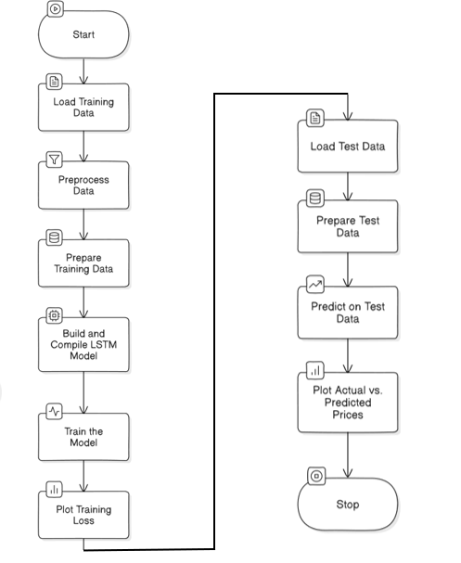

Figure : Flow Diagram

## Sequential diagram:

The sequential diagram outlines the process of the "Investor Analysis on Stock Market" project. It starts with defining project objectives and collecting data, which is then preprocessed. The data feeds into the model's conceptualization, translation, verification, and validation stages. The validated model is used for experimental design, producing and analyzing results. Additional runs refine the model before final documentation and implementation. This structured sequence ensures thorough

Development and analysis of Stock market model.

# Project Planning:

Project planning is a critical phase in any project, especially when dealing with complex and dynamic fields like stock market analysis. Effective project planning ensures that all tasks are organized, resources are allocated efficiently, and timelines are adhered to, ultimately leading to the successful completion of the project.

In the context of our project, "Investor Analysis on Stock Market," the project planning phase involves several key components:

1. **Problem Formulation:** Define the specific issues or challenges faced by investors in stock market analysis. Clearly articulate the need for advanced simulation techniques to enhance predictive accuracy and decision-making in a volatile market environment.
2. **Setting of Objectives and Overall Project Plan:** Establish clear objectives for the project, such as improving the reliability of stock market predictions and providing investors with actionable insights. Develop an overall project plan outlining the key milestones, deliverables, and timelines.
3. **Model Conceptualization:** Create a conceptual model representing the stock market dynamics, focusing on factors such as buying and selling pressures, market trends, and economic indicators. This model will serve as the foundation for the simulation.
4. **Data Collection:** Gather relevant data from reliable sources, including historical stock prices, economic indicators, and market sentiment. Ensure that the data is accurate, complete, and representative of the market conditions to be analyzed.
5. **Model Translation:** Convert the conceptual model into a formal simulation model using Python-based tools like Jupyter Notebook, Pandas, and TensorFlow. This step involves coding the algorithms and setting up the computational framework.
6. **Verification:** Verify that the simulation model is functioning as intended by checking for errors in the code and ensuring that the model accurately represents the conceptual framework. This step is crucial for preventing inaccuracies in the analysis.
7. **Validation:** Validate the simulation model by comparing its outputs with real-world data and historical trends. This step ensures that the model produces realistic and reliable results, reflecting actual market behavior.
8. **Experimental Design:** Design experiments to test various scenarios and hypotheses within the simulation. This involves determining the parameters to be varied, the number of simulation runs, and the metrics for evaluating the outcomes.
9. **Production Runs and Analysis:** Conduct production runs of the simulation, generating outputs for analysis. Analyze the results to identify patterns, trends, and potential investment opportunities or risks.
10. **More Runs:** Based on the initial analysis, conduct additional simulation runs to refine the model, explore alternative scenarios, or gather more data for robust conclusions.
11. **Documentation and Reporting:** Document the entire simulation process, including the methods used, data sources, and key findings. Prepare a comprehensive report that presents the results, insights, and recommendations for investors.
12. **Implementation:** Implement the insights and recommendations derived from the simulation into real-world investment strategies. This step involves applying the findings to actual stock market decisions and monitoring the outcomes.



# Expected Outcome:

1. Data Loading and Pre-processing: The code begins by loading training data from a CSV file containing historical stock prices of a particular company (e.g., Google). The data is then pre-processed, which involves handling missing values and converting data types to ensure data integrity.

2. Model Training: After pre-processing, the data is split into input (X_train) and output (Y_train) sequences to train the Long Short-Term Memory (LSTM) model. The LSTM model architecture consists of multiple LSTM layers with dropout for regularization, followed by a dense output layer. The model is trained using the prepared training data with the Adam optimizer and mean squared error loss function.

3. Training Loss Visualization: During training, the loss of the model is recorded and plotted over epochs to visualize the training progress. This plot helps to monitor the model's performance and identify any trends or patterns in the training process.

4. Model Evaluation: Once the model is trained, it is evaluated using test data from another CSV file. The test data undergoes similar pre-processing and scaling steps as the training data. The trained model then makes predictions on the test data to forecast future stock prices.

5. Prediction Visualization: The actual stock prices from the test data and the predicted prices generated by the model are plotted on a graph to compare their trends visually. This visualization helps assess the accuracy and effectiveness of the model in predicting stock prices.

6. Performance Assessment: By comparing the actual and predicted stock prices, we can assess the performance of the LSTM model in capturing the underlying patterns and trends in the stock market data. The goal is to achieve accurate predictions that closely match the actual prices, indicating the model's effectiveness in analyzing and forecasting stock prices.

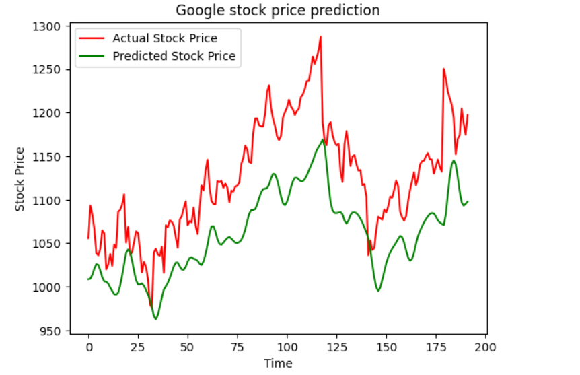Overall, the expected outcome of the provided code is to train an LSTM model on historical stock price data, evaluate its performance on test data, and visualize the model's predictions compared to actual stock prices. This process enables analysts to make informed decisions and predictions in the dynamic landscape of financial markets.

# Conclusion:

In conclusion, the "Investor Analysis on Stock Market" project stands as a testament to the power of advanced simulation and modeling techniques in transforming financial analysis. By systematically addressing each stage of the simulation process—from problem formulation to model implementation—the project ensures a robust framework for understanding market trends and predicting future stock movements. The detailed steps, including problem formulation, model conceptualization, data collection, and extensive validation, underscore a comprehensive approach to financial analysis.

The use of Long Short-Term Memory (LSTM) networks within this project exemplifies the application of cutting-edge machine learning algorithms to capture complex patterns in stock prices. The iterative nature of model training and validation, coupled with thorough data preprocessing and experimental design, enhances the accuracy and reliability of predictions. This methodical approach not only provides valuable insights into market dynamics but also equips investors with practical tools to make more informed and strategic decisions.

Furthermore, the project's focus on visualizing results through comparative analysis of actual and predicted stock prices adds a critical layer of evaluation, allowing for the assessment of model performance and its practical implications. By integrating these advanced techniques with practical market data, the project highlights the potential for simulation and modeling to significantly improve investment strategies and decision-making processes.

Overall, the project demonstrates that leveraging sophisticated computational methods and thorough analytical frameworks can substantially enhance stock market analysis, providing a more nuanced and actionable understanding of market behavior. This approach not only addresses the limitations of traditional methods but also offers a forward-looking perspective on financial forecasting and investment strategy development.

Figure 1: Use case Diagram 7

Figure 2: Flow Diagram 9

Figure 3: Sequence Diagram 10

Figure 4: Sequence Diagram 10